HackerEarth - Factorial!
Code:
#include <stdio.h>

int main() {
int n;
scanf("%d", &n);

long long fact = 1;
for (int i = 1; i <= n; i++) {
fact = fact * i;
}

printf("%lld\n", fact);
return 0;
}

Screenshot:
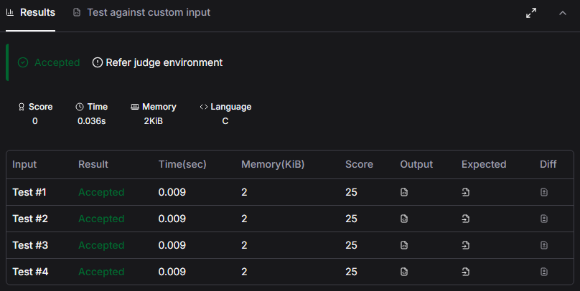

Link:
https://www.hackerearth.com/practice/basic-programming/input-output/basics-of-input-output/practice-problems/algorithm/find-factorial/

